|  |
| --- |
| Study Match |
| Image result for gsu logo |

|  |  |
| --- | --- |
| 3/28/2018 | Group name: Panther Coders |

|  |
| --- |
| Software Engineering (CSc 4350) - Spring 2018 Members: Ever Lopez, Hamza Padania, Mohammedzaeem Momin, SanHwan Park, Dung Dang |

**a) Planning and Scheduling:**

o What is the single most serious challenge you see in developing the product on schedule?

We may not have enough expertise to complete the coding on time.

o Write down 2+ risks you can foresee in completing this project

(table below)

o Ways to avoid or lessen/ minimize the risks

(table below)

|  |  |  |  |
| --- | --- | --- | --- |
| Risk | Affects | Description | Minimize Risks |
| Product Competition | Business | Most students make GroupMe in each of their classes, which allows them to reach out to the people in their class There are many large Facebook groups based at GSU (Book Exchange) | We need to make aggressive advertising for the site. We can also add a report function for when a study partner is using the site for reasons other than intended and ban the user if verified. |
| Programming Delay | Project | Not having enough time to program enough features and security measures necessary for this product. | Plan accordingly based on a tight schedule. |
| Size Underestimation | Project and Product | Underestimating the necessary size of the system, based on the number of users now and future. | Perform a school wide survey to get an approximation of how many students will be using the system. |
| Resources | Project | Having the capability to house this system in terms of servers or other required hardware. | Potential Solution: partner with a company or organization that has the bandwidth to maintain the system. |

**▪ Scheduling**

|  |  |  |  |
| --- | --- | --- | --- |
| Task | Effort (person-days) | Duration (hours/or days/ etc) | Dependencies |
| 1.Communicating on slack | 5 | 2 hours per person | N/A |
| 2.Meetings | 5 | 6 hours per person | Task 1 |
| 3. Use Cases | 0 | 0 hour per person | Task 2 |
| 4. Use Case Diagrams | 2 | 2 hours per person | Task 3 |
| 5. Test Cases | 0 | 0 mins per person | Task 4 |
| 6. Class Diagram | 5 | 2 hours per person | Task 5 |
| 7. Sequence Diagram | 5 | 2 hours per person | Task 6 |
| 8. System Design Diagram | 5 | 2 hours per person | Task 7 |
| 9. Implement the System Design | 5 | 10 hours per person | Task 8 |
| 10. System Testing | 2 | 3 hour per person | Task 9 |
| 11. Test Documentation | 1 | 1 hours per person | Task 10 |
| 12. Video | 5 | 30 mins per person | Task 11 |
| 13. Video Editing | 1 | 2 hours per person | Task 12 |

**b)**

**----------------------------------------------------Use Cases------------------------------------------------------**

* **Identifier:1**
* **Iteration: 1**
* **Summary: GSU email sign up and verification**
* **Actors: User, Database**
* **Basic Course of Events:**

1. **User signs up for an account to use the system**
2. **System sends verification email**
3. **User verifies GSU email via system-generated email**

* **Alternative Paths: None**
* **Exception Paths:**

**1. User enters non-GSU email.**

**3. User can’t reuse the email.**

* **Extension Points: User is allowed to create new account**
* **Trigger: User is in need of study community within GSU**
* **Assumptions: User is a GSU student**
* **Precondition: User must have a valid GSU email**
* **Postcondition: User requirements are sufficient to create account**
* **Author: All**
* **Date: 02/14/2018 (Revised: 3/5/2018)**

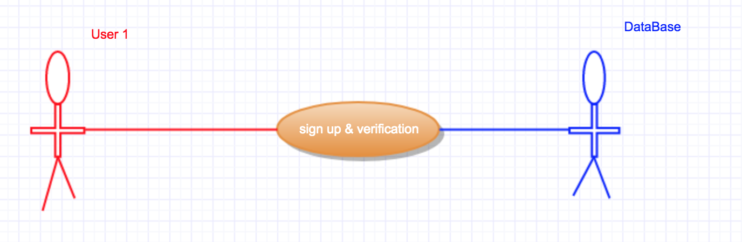

* **Identifier: 2**
* **Iteration: 1**
* **Summary: Create new account and create password**
* **Actors: User, Database**
* **Basic Course of Events:**

1. **User directed to log in creator page after successful verification.**
2. **User prompted to create password; Password must be at least 8 characters long and must include at least one special character.**
3. **User proceeds to login**

* **Alternative Paths: If user enters invalid password, system prompts user to try again**
* **Exception Paths:**

**1. User enters password that does not meet the requirements**

* **Extension Points: User is allowed to create account**
* **Trigger: User clicks on verification link to bring them to account creation page**
* **Assumptions: Username is panther email address**
* **Precondition: Student has verified their GSU email successfully**
* **Postcondition: User requirements are sufficient to create account**
* **Author: All**
* **Date: 02/14/2018; (Revised 3/5/2018)**

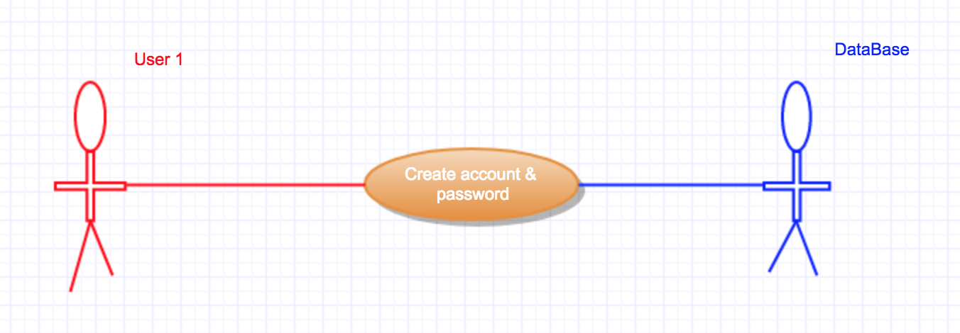

* **Identifier: 3**
* **Iteration: 1**
* **Summary: User redirected to web page home screen**
* **Actors: User, Database**
* **Basic Course of Events:**

1. **User enters email and password**
2. **User logs in**

* **Alternative Paths: User doesn’t log in/forgot password**
* **Exception Paths: Wrong username, wrong password**
* **Extension Points: User accesses system database**
* **Trigger: User has credentials to log in**
* **Assumptions: User has successfully registered to use the system (see identifier 2)**
* **Precondition: User has successfully created login credentials to access system**
* **Postcondition: User can search for partner(s) needing help in similar areas**
* **Author: All**
* **Date: 02/17/2018 (Revised: 3/5/2018)**

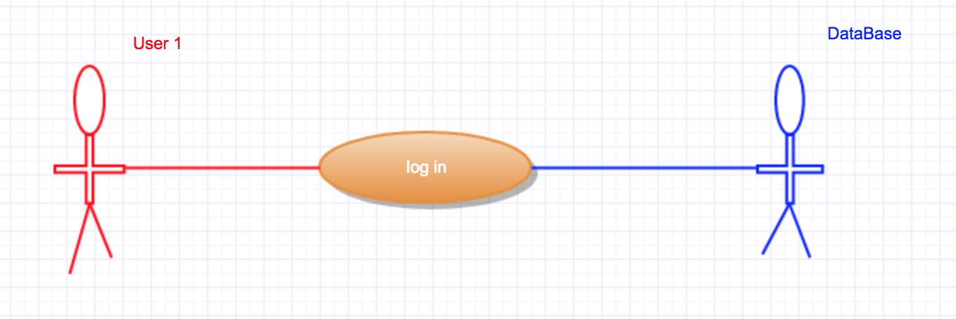

* **Identifier: 4**
* **Iteration: 1**
* **Summary: User creates personal profile**
* **Actors: User, Database**
* **Basic Course of Events:**

1. **User directed to profile creation page**
2. **User enters personal details (Name, Age, Sex)**
3. **User is required to enter major, classes, type of student (undergrad vs grad, further classification optional), expertise with feedback, and time availability**

* **Alternative Paths: User doesn’t enter information**
* **Exception Paths: User enters invalid classes or major**
* **Extension Points: User allowed to move on toward searching for study partner(s) and/or post and discuss their questions and topic on the discussion board**
* **Trigger: User logs in for the first time**
* **Assumptions: User has created an account**
* **Precondition: User has a valid account (see identifier 3)**
* **Postcondition: User can search for study partner(s)**
* **Author: All**
* **Date: 02/17/2018; (Revised 3/5/2018)**

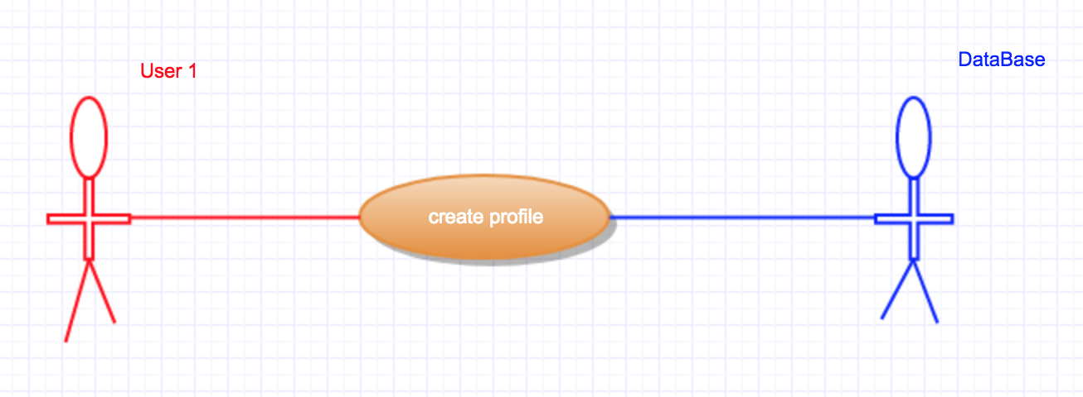

* **Identifier:5**
* **Iteration: 1**
* **Summary: User is now able to search for potential study partner(in person or online)**
* **Actors: User, Database**
* **Basic Course of Events:**

1. **User can access search option from home screen**
2. **User can filter based on major, course, rating level, student type, study location, and time availability**
3. **List of potential matches based on filter parameters and their profile is provided to User**

* **Alternative Paths: User can search for discussion boards**
* **Exception Paths: User is not accepted by any potential matches**
* **Extension Points: User can then set up a study time and place**
* **Trigger: User is in search of academic help**
* **Assumptions: User is looking for a tutor, study partner, or study guides after creating an account**
* **Precondition: User has created and built their profile, and is looking for academic assistance or is interested in providing academic assistance**
* **Postcondition: User can now collaborate with their study match however best fits their needs, online or in person**
* **Author: All**
* **Date: 02/19/2018 (Revised: 3/5/2018)**

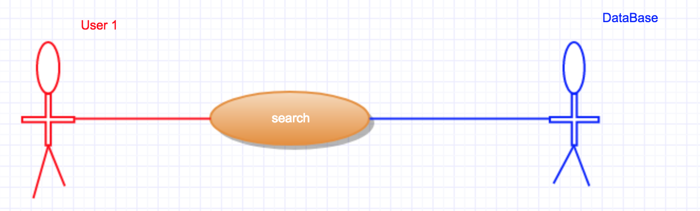

* **Identifier: 6**
* **Iteration: 1**
* **Summary: Users 1 and 2 get matched with each other**
* **Actors: User1 (formerly User), Database, User 2**
* **Basic Course of Events:**

1. **User 2 is given the option of accepting the match request**
2. **Users 1 and 2 are notified of match**
3. **Database now allows communication between each user**

* **Alternative Paths: None**
* **Exception Paths: User 2 does not match with User 1**
* **Extension Points: User can then set up a study time and place**
* **Trigger: User 1 wants to be tutored or find a study buddy**
* **Assumptions: User is looking for a tutor, study partner after creating an account**
* **Precondition: User has created and built their profile, and is looking for a match**
* **Postcondition: User can set up meeting time and location with partner**
* **Author: All**
* **Date: 02/19/2018 (Revised 3/5/2018)**

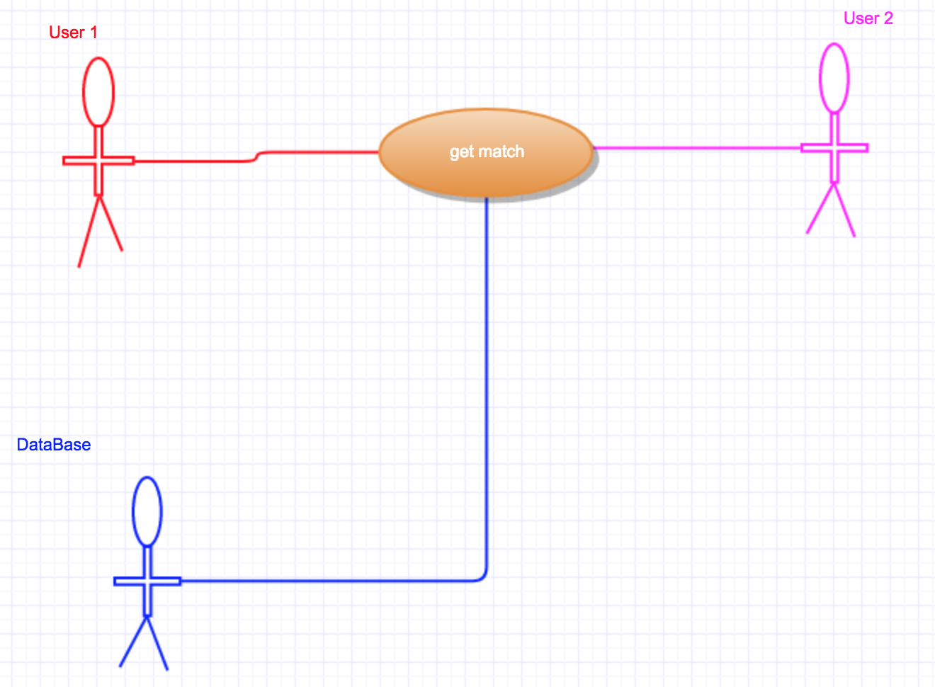

* **Identifier: 7**
* **Iteration: 1**
* **Summary: Based on “Online Match” filtered option, matched users are given the option to start/join new study chat**
* **Actors: User 1, Database, User 2**
* **Basic Course of Events:**

1. **Users have “Start New Chat” feature available to them**
2. **Matches are able to join new chat and continue their study match as needed, be it tutoring session or study collaboration**
3. **If needed, chat supports file sharing**

* **Alternative Paths: Users can exercise discussions boards or pursue study match in person**
* **Exception Paths: Users decide not to utilize online feature of system**
* **Extension Points: User can then collaborate, share knowledge, and/or learn from each other**
* **Trigger: User is in search of academic help**
* **Assumptions: User is looking for a tutor, study partner**
* **Precondition: User has created and built their profile, and is looking for academic assistance or is interested in providing academic assistance**
* **Postcondition: User can now collaborate with their study match however best fits their needs, online**
* **Author: All**
* **Date: 02/19/2018 (Revised: 3/5/2018)**

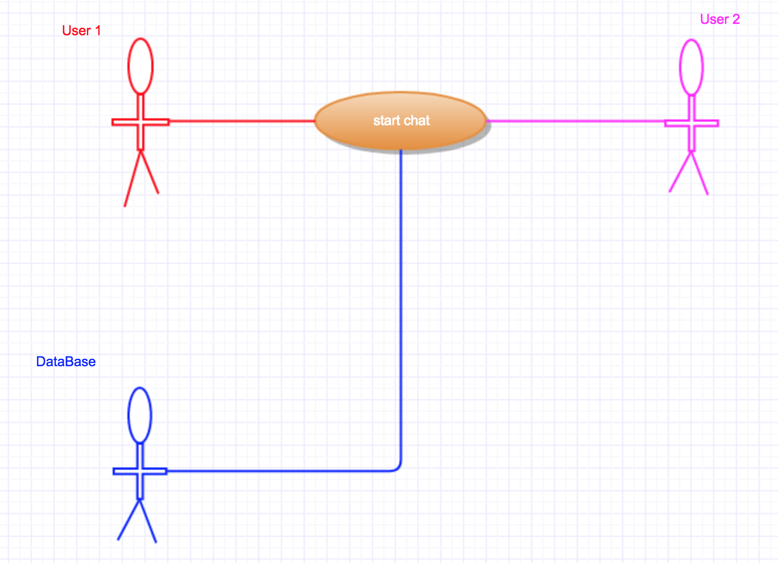

* **Identifier: 8**
* **Iteration: 1**
* **Summary: Discussion board feature is available to users to post their questions or discussion topics**
* **Actors: User, Database**
* **Basic Course of Events:**

1. **User have the option of utilizing the discussion board feature to post more specific questions or discuss matters pertaining to their classes**
2. **User can utilize the “New Post” option**
3. **When creating a new thread, user must enter a subject and message**
4. **User must select relevant class for filtering purposes**

* **Alternative Paths: Users can exercise Online chat or pursue study match in person**
* **Exception Paths: None**
* **Extension Points: Another user can respond to the original post.**
* **Trigger: User has a specific question or would like to openly dis*-cuss something pertaining to their question.**
* **Assumptions: User would like academic help from their peers**
* **Precondition: User has created and built their profile, and is looking for academic assistance or is interested in providing academic assistance**
* **Postcondition: Users will get a response to their thread from other users**
* **Author: All**
* **Date: 3/6/2018, (Revised: 3/7/2018)**

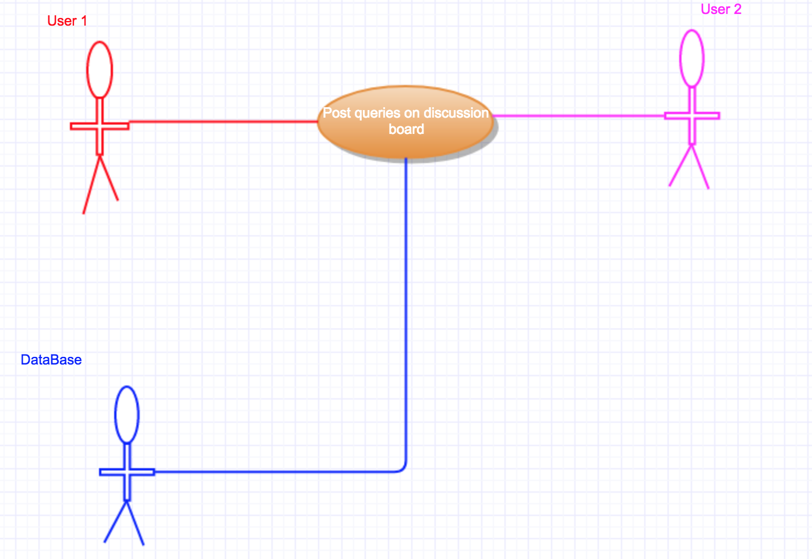

* **Identifier: 9**
* **Iteration: 1**
* **Summary: Users can read and respond to a post in the discussion board**
* **Actors: User, Database**
* **Basic Course of Events:**

1. **User can read other users’ post containing topic or question**
2. **User can utilize the “Reply” option**
3. **Reply is posted underneath original post**

* **Alternative Paths: Users can exercise Online chat or pursue study match in person**
* **Exception Paths: None**
* **Extension Points: Original user or other readers can rate the answer**
* **Trigger: User has a response or answer to a specific question or topic**
* **Assumptions: User would like to provide academic help to their peer**
* **Precondition: User has created and built their profile, and is interested in providing academic assistance**
* **Postcondition: User’s’ comment will be posted as a response and potentially get rated**
* **Author: All**
* **Date: 3/6/2018, (Revised: 3/7/2018)**

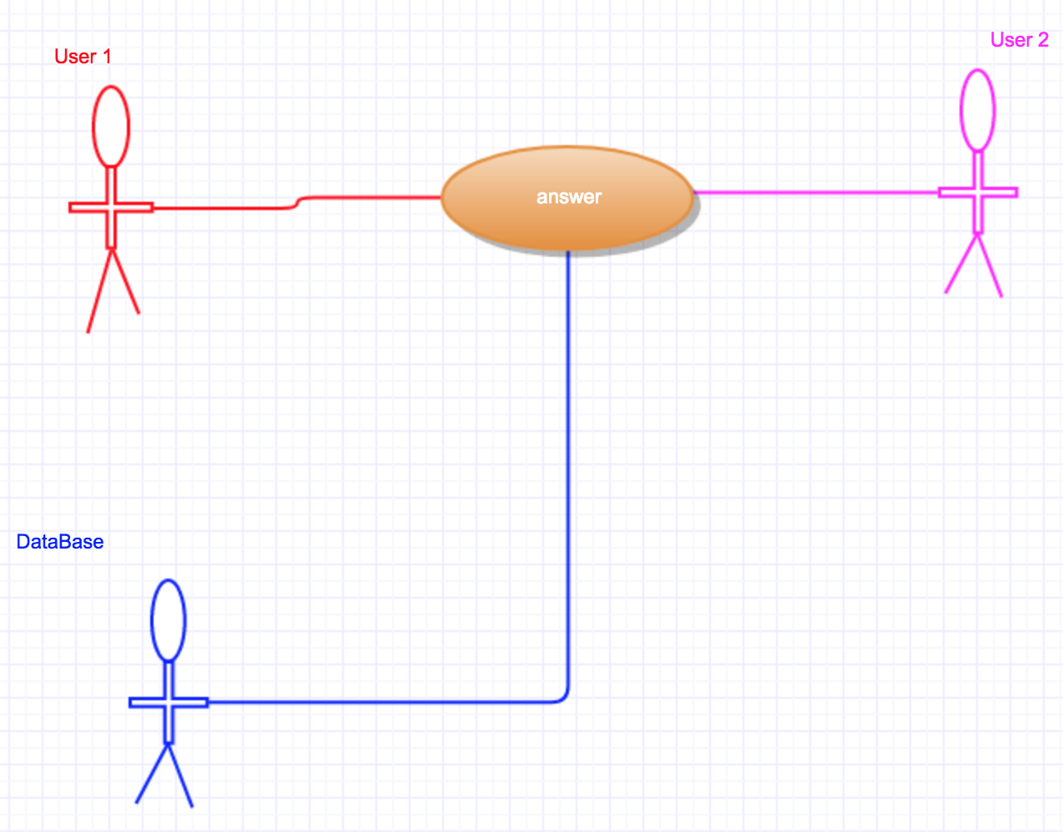

* **Identifier: 10**
* **Iteration: 1**
* **Summary: The original poster can mark the original post as solved**
* **Actors: User, Database**
* **Basic Course of Events:**

1. **Original poster(User) reads the responses on his thread**
2. **User can mark the response solved if they are content with an answer**

* **Alternative Paths: Original poster(User) does not mark any responses “Answered”**
* **Exception Paths: None**
* **Extension Points: None**
* **Trigger: User searching for answer to their thread**
* **Assumptions: User would like to receive an answer to their thread**
* **Precondition: User has created a thread**
* **Postcondition: Thread is marked “Answered”**
* **Author: All**
* **Date: 03/06/2018, Revised: (3/7/2018)**

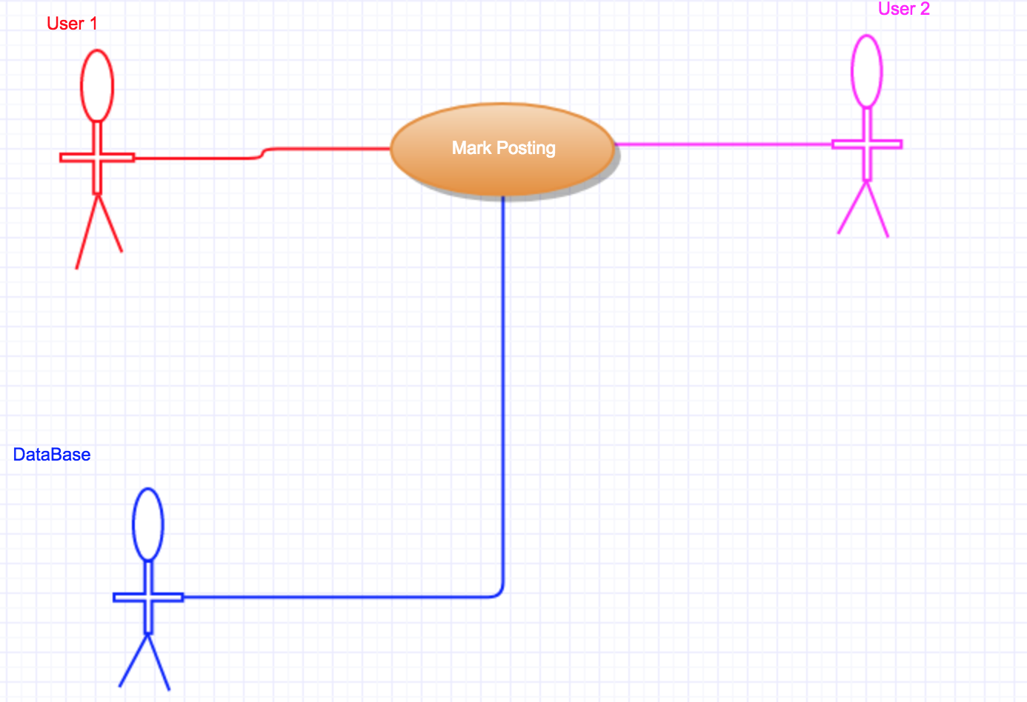

* **Identifier: 11**
* **Iteration: 1**
* **Summary: Users can rate a thread with a “Thumbs up” or “Thumbs down”**
* **Actors: User, Database**
* **Basic Course of Events:**

1. **Users read threads and comments**
2. **User can rate the threads and comments with a thumbs up or thumbs down**

* **Alternative Paths: User can comment or leave thread**
* **Exception Paths: None**
* **Extension Points: None**
* **Trigger: User is in search for academic help**
* **Assumptions: User has some knowledge over the subject matter**
* **Precondition: User browsing through threads**
* **Postcondition: Comment is rated “Thumbs up” or “Thumbs down”**
* **Author: All**
* **Date: 03/06/2018, (Revised: 3/7/2018)**

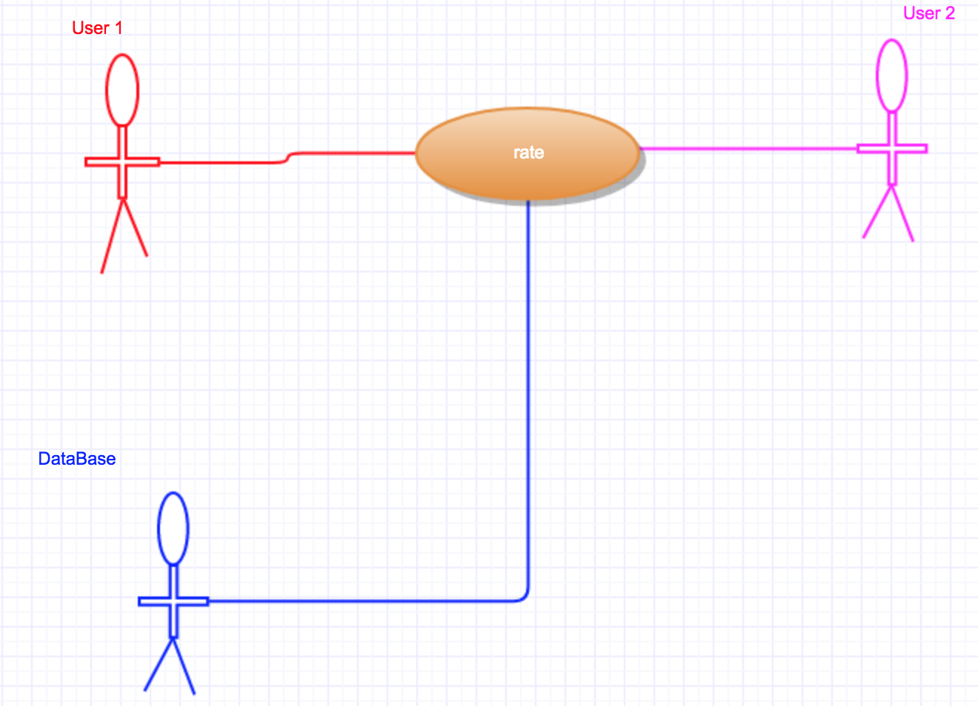

**-----------------------------------------------------Test Cases--------------------------------------------------------**

1. **Sign Up and Verification**

|  |  |
| --- | --- |
| Description: | Ensures that a valid GSU student can sign up. |
| Test Inputs: | GSU email to verify. |
| Expected Results: | Verification email is sent to the GSU email. |
| Dependencies: | None |
|  |  |
| Test Steps | 1. Form values are not left blank. 2. Entered email ends with student.gsu.edu 3. Password is valid. 4. Verify that the retrieved email doesn't already exist in database. 5. Send verification email. 6. Confirm sign up. 7. Save user into Users database. |
| Owner: | All team members (Revised: 3/7/18) |

1. **Create Account**

|  |  |
| --- | --- |
| Description: | User will be allowed to enter study match website. |
| Test Inputs: | GSU email and password. |
| Expected Results: | User will enter initial home page and password will be stored in database. |
| Dependencies: | Sign up and verification step |
| Test Steps: | 1. Enter login page 2. Set password 3. Password will be stored in database. 4. User succeed to login |
| Owner: | All team members (Revised: 3/7/18) |

1. **Login**

|  |  |
| --- | --- |
| Description: | Ensures that only registered student can access the system. |
| Test Inputs: | GSU email and password. |
| Expected Results: | User is allowed an access to the system. |
| Dependencies: | User need to create account. |
| Initialization: | Users database is loaded. |
| Test Steps | 1. No fields are left empty. 2. Entered email and password exists in database. 3. User is redirect to the system. |
| Owner: | All team members (Revised: 3/7/18) |

1. **Create Personal Profile**

|  |  |
| --- | --- |
| Description: | User will create their profiles in order to communicate |
| Test Inputs: | Name, Major, Classes, approximate available time, type of student (undergrad or grad) |
| Expected Results: | User profile information will be saved into database. |
| Dependencies: | User log in. |
| Test Steps: | 1. Fill in username, major, classes, student type(undergrad or grad)available time. 2. Profile information is saved in database. 3. Users have personal profile. |
| Owner: | All team members (Revised: 3/7/18) |

1. **Search Study Partner**

|  |  |
| --- | --- |
| Description: | Users will search their potential study partner for study |
| Test Inputs: | Major, course, approximate available time, rate, level, location and student type. |
| Expected Results: | User will find their study partner based on their searching conditions. |
| Dependencies: | User’s profile |
| Test Steps: | 1. Select conditions 2. Search study partner 3. System will show potential study colleague 4. User will accept recommend or deny |
| Owner: | All team members (Revised: 3/7/18) |

1. **Matching**

|  |  |
| --- | --- |
| Description: | User1(formerly) request study match, User2 will accept or deny. |
| Test Inputs: | None |
| Expected Results: | Users will get matched each other. |
| Dependencies: | Search study partner |
| Test Steps: | 1. User 2 will accept User1’s request or deny 2. If User 2 accept 3. User1 and User2 will be notified 4. Server will allow communication between User1 and User2 |
| Owner: | All team members (Revised: 3/7/18) |

1. **Chat**

|  |  |
| --- | --- |
| Description: | Users who are filtered based on their condition are able to chat together for studying. |
| Test Inputs: | None |
| Expected Results: | Users can now select a location from the list of available GSU buildings and approved locations.  Users 1 and 2 can agree on a time and  Database records both user’s choices and proposes it to the other |
| Dependencies: | Match |
| Test Steps: | 1. User 1 and 2 send message to each other. 2. Select location and time 3. Users agree 4. Database records will make potential participants to know this meeting |
| Owner: | All team members (Revised: 3/7/18) |

1. **Posting on discussion board**

|  |  |
| --- | --- |
| Description: | Users can user discussion board instead of studying in person |
| Test Inputs: | posting |
| Expected Results: | Users can use discussion board to post to ask about their study questions. |
| Dependencies: | Create personal profile |
| Test Steps: | 1. User post their question on the discussion board 2. Database will records questions. |
| Owner: | All team members (Revised: 3/7/18) |

1. **Answer**

|  |  |
| --- | --- |
| Description: | Users can respond to a past discussion board after they read |
| Test Inputs: | comments |
| Expected Results: | Users can share their studying and respond on the discussion board |
| Dependencies: | discussion board |
| Test Steps: | 1. Users read the post that is related to their studying 2. Users would respond 3. Database records will keep in the future for other users |
| Owner: | All team members (Revised: 3/7/18) |

1. **Mark**

|  |  |
| --- | --- |
| Description: | Users can mark the original posters |
| Test Inputs: | Mark |
| Expected Results: | Users can mark the original poster if they are content with an answer |
| Dependencies: | Respond |
| Test Steps: | 1. Original Poster(Users) read the response on their thread 2. Users can mark it as solved 3. Database will keep marked threads |
| Owner: | All team members (Revised: 3/7/18) |

1. **Rate**

|  |  |
| --- | --- |
| Description: | Users can rate thread with “Thumbs up” and “Thumbs down” |
| Test Inputs: | “Thumbs up” and “Thumbs down” |
| Expected Results: | Users will rate people who joined study match or comments, and the rate will be shown on their profile. |
| Dependencies: | Chat and Discussion board |
| Test Steps: | 1. Users rate posting by “thumbs up” or “thumbs down” 2. The result will be stored in database. 3. Database records will be kept in the future. |
| Owner: | All team members (Revised: 3/7/18) |

**System Use Case Diagram**

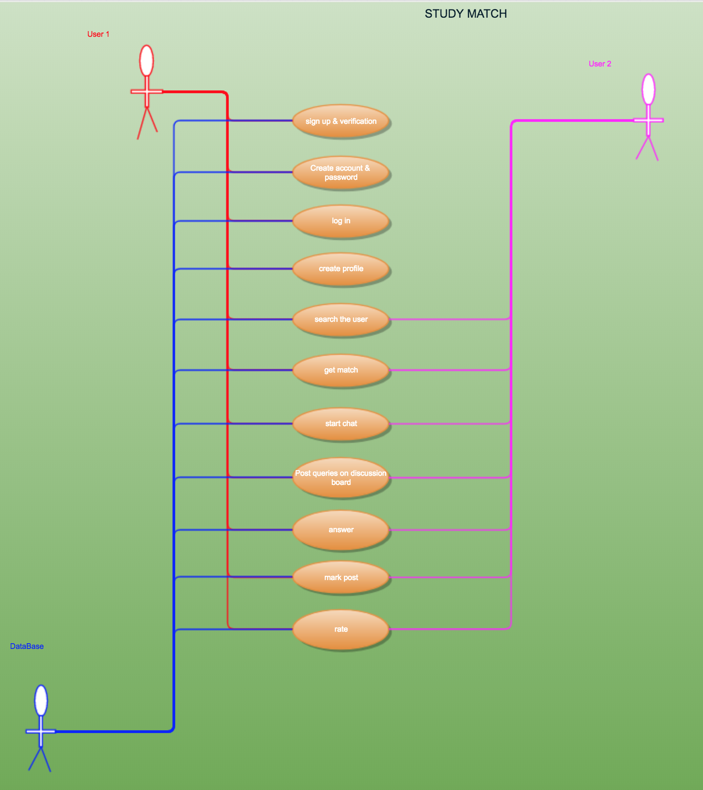

**b) System Modeling**

**Class Diagram**

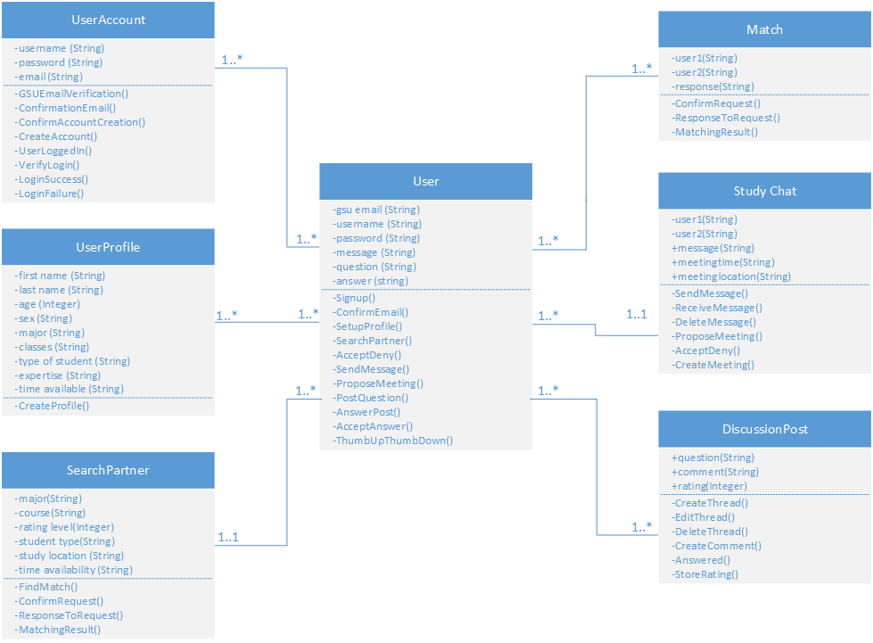

**Sequence diagram**

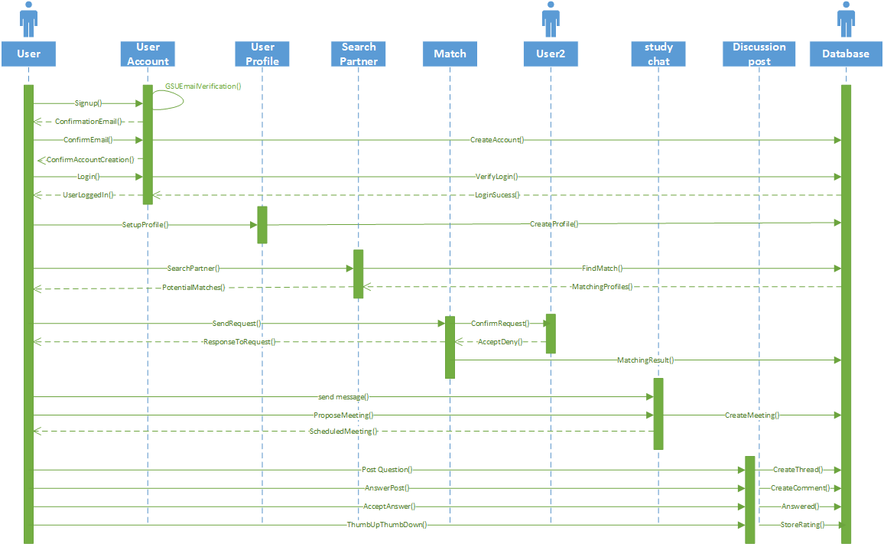

[**Sequence Diagram Link**](https://github.com/mmomin12/SE-Project/blob/master/SequenceDiagram.png)

**c) System Architecture**

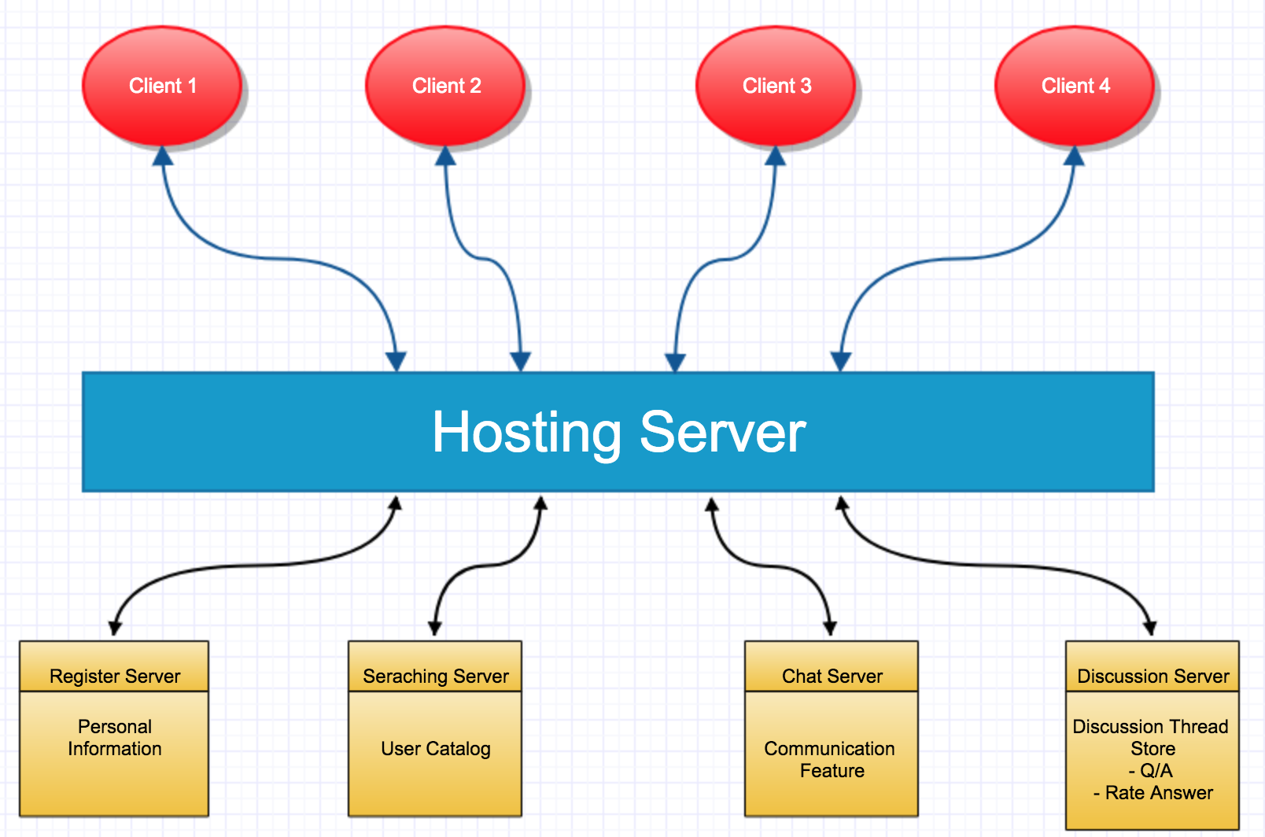

**d) Implementation of System Design**

[**Study Match**](https://planted-comments.000webhostapp.com/Register.php)

**e) Test Documentation**

|  |  |  |  |
| --- | --- | --- | --- |
| **Bug** | **Test That Uncovered The Bug** | **Description of Bug** | **Action Taken** |
| Email Verification | Tester entered email for registration | Email verifying student’s GSU email not sending | Set up email server |
| Log in error | Tester entered invalid username/password | When invalid credentials are entered, sign in continues to next page | In progress; coding to stop form submission if username/password invalid |

**f) Video**

https://github.com/mmomin12/SE-Project.git